[Turing for Dummies (AI) — Part 1](https://gordicaleksa.medium.com/turing-for-dummies-ai-part-1-f0f668bcd83d) RECAP touring test

*Can machine think?* Detecting where a machine is intelligence or not. Question to complex ⟹ imitation game.

Turing replace something related to psychological to something that can be valuated and is empirical. There are objective criteria that you can give to the success or failure of the turing test

## Contrary Views on the Main Question - page 442

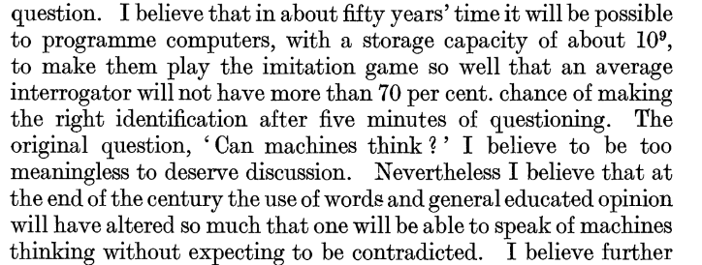

The second part didn’t become true. The majority of us still undecided about the definition of machine thinking. Is an empirical criteria that can or can not be satisfied.

**Section 6**

9 objection considered by Turing.

## **1. The theological objection**

**Objection**: the sould is necessary for thinking and God gave soul only to men and women. (weak argument, Turing don’t spend much time here)

Thinking depending on having the soul, and god gived it only to man (and woman) but not animals or machines. ⟹ machine can not think because they do not have any soul. Turing: theological arguments are not very strong because they are based on faith (Muslims believe that God gave souls only to man). Tjrought human history we have proven that many religious ideas are wrong (geocentric proved wrong by Copernicus)

## **2. The heads in the sand objection**

**Objection**: the idea of machines thinking is too scary, so it’s not possible. Only humans can think! We’re special (weak argument, Turing don’t spend much time here)

Usually is the argomenent use by the people who used the theological one (the one before)

the coneseuqneuce of having thinking machine is too dreadful and so we will ignore hoping it will never happens.

People can maintain their supremacy if they go fully cyborg by porting their souls to machines (?)

## **3. The mathematical objection**

**Objection**: there are things that even the most powerful computers (with infinite capacity) can not compute. And so they can not give a correct answer.

It is a well-known fact in theoretical computer science and logic

Turing: aware of this limitation but there is no proof that human intellect is not subject to the same kind of limitations

godel incomplete theorem. Formal system are strong enough to express arithmetic. If there is a formal system that is at least as strong to express arithmetic then assuming that the system is consistent there are true statements that can not be proved. For something strong enough to express interesting things that are things that are true but can not be proved (axiosm). The idea is that machines that are computed thighs have intrinsic limitations (never be able to prove all true statements, not able to prove their own consistency)

Machines as it where are limited. always stop (wrong answer or not able to give an answer).

Turing: problem to apply Godel theorem. When you are doing the limitation game you try to compute question in such a way it will give wrong answers. Can give us some sense of superiority but is temporarily and not possible to formulate a question that can trick all the machine simultatinous.

Even if we assume that godel incomplete theorem applied to machine. It still not been shown that something similar does not holds to humans (humans also make mistakes) we can wrongly answer to question.

There are always logical things that can not be proved. The system can not justify itself. Use always axioms that are neither right or wrong.

Limitation of the problem of discrete-state machine. Machine with infinite capacity

Give wrong answer or fail to give one (but much time allowed for reply)

"*Consider the machine specified as follows. . . . Will this machine ever answer ' Yes ' to any question?*"

Disability of the machine if the human intelligent is not subject. Limitations to the powers of any particular machine, it has only been stated, without any sort of proof, that no such limitations apply to the human intellect.

**Objection**: Machine is based on an assumption, artificial intelligence works as logical machine and then can not answer to all the quesion. godel theorem applied to the machine. Since computers only contained a finite number of instructions (or programs), it can be argued, they could not reproduce human intelligence. Turing called this the “mathematical objection” to his view that machines can think. Impossible to have a set of rules that can explain everything Machine are logical systems based on mathematical and logical rules; as Godel states, these systems can not be proved to be real, for example in real number, we still have concerns with the concept of infinity thus, since a machine can not prove to be right, we are sure that it is not able to answer to the question to act like a specific machine, thus from the logical and mathematica point of view, they are wrong

GODEL: if we have a coherent set of axioms without any contradiction when it is not complete

## **4. The argument from consciousness**

**Objection**: even if computers exhibit creativity it’s not the same thing because they are not conscious nor do they fell emotions. Only way to know that a man thinks is to be that man.

Hypotethically: if they were able to exhibit creativity and win the imitation game how do you know that they are not conscious?

Solipsists view: you describe consciousness to other humans because they *appear* to have one

Likewise according to this view the only way to know that a man thinks is to be that particular man.

How do you describe creativity?

OBJECTION

Only way to know that a man thinks is to be that man

How do you know that someone feels emotions. Even if we don’t understand certain things we can not prove that

Nonsectuor. Somethings that does not follows up.

If you have covid you cought, if you cought you have covid. Look like it does but it does not follow up.

Seems that if machine does not have consciousness or feels pleasure then it can not really be intelligent. The only way to know that a machine/person think is to be that particular machine/person. The only way to know that something is conscious is to be that thing. Is not really a replay to the objection.

Consciousness is require for intelligence.

**Strong Ai**: machine is intelligecnet have same ability of human in whild range of things. Machine that is also conscious in some parameters. In order to a machine to be intelligent it has to be conscious. Hard to know what consciousness is.

**General AI**:

## **5. Arguments from various disabilities**

**Objection**: sure that a machine can do all those things, but they can’t do X

X = {sense og humor, fall in love, do something really new…}

This is based on the principle of inductive reasoning. You see the current and past computers and you conclude that the’ll never be able to do X

Mistakes. The machine can make mistakes as humans. Some traist human machie are the same but other instead are unique.

**Error vs function**. We ignore error in fucntiongging because those type of error were made by human desgining/programmmign the machine

Machine produces an output that is irrelevant. Is us that assign a certain meaning to the output (not the machine) is us that we decide that is irrelevant or is something that we are not interested of.

Is our itnerpreation of what the machine does. The output follows without any mistakes of functions.

Machine became better but they are also different, different from the one discuess by Turing. In past fiew decades another approach emerged. If a machine is trained in certain behaviour then becomes better at imitating states and emotions. **Scientific induction**: when you observe 100 birds that flys then you conclude that all the birds flying. But one single instance can make your induction fall. If the premises are true than you guarantee that the conclusion are true.

Valid = the conclusion has to be true if the premises are true

Deduction does not create new knowledge but is only potentation because it might actually be false.

## **6. Last Lovelance’s objection**

**Objection**: computers can’t create, they can only do stuff that we progrm them to do (aka only the things they know how to do).

Turing reforumlates: *machines can never “take us by surprise”*. Computer instead surprise us. Nowadays it changes with the arrival of machine learning and deep learning.

First half 900 century song of Lord Bayron (poet). She marry a guy. And translate a paper of Luigi Malerva that was making comments about the first mechanical (not electrical) machine. Not something that can only do calculation but can be programmed. First universal machine (can be program with punch cards) and outputs cards forated that can be read.

She added her own notes. Relefect about the power of the machine. In that context she makes these remarks.

OBJECTION: machine can only do whatever they know to perform (akak what they are programmed for) Machine can think and process new things.

Turing ⟹ *Machines can not do new things* as human we can also not do something relay new. Whatever we do is based on our thoughts.

Turing ⟹ *machines can never “take us by surprise”*. We can be surprise by the machine.

**Closure analogical consequences**: if you come to believe than today is sunny. You can conclude that there is life in mars (?). As soon as something is presented there is nothing new.

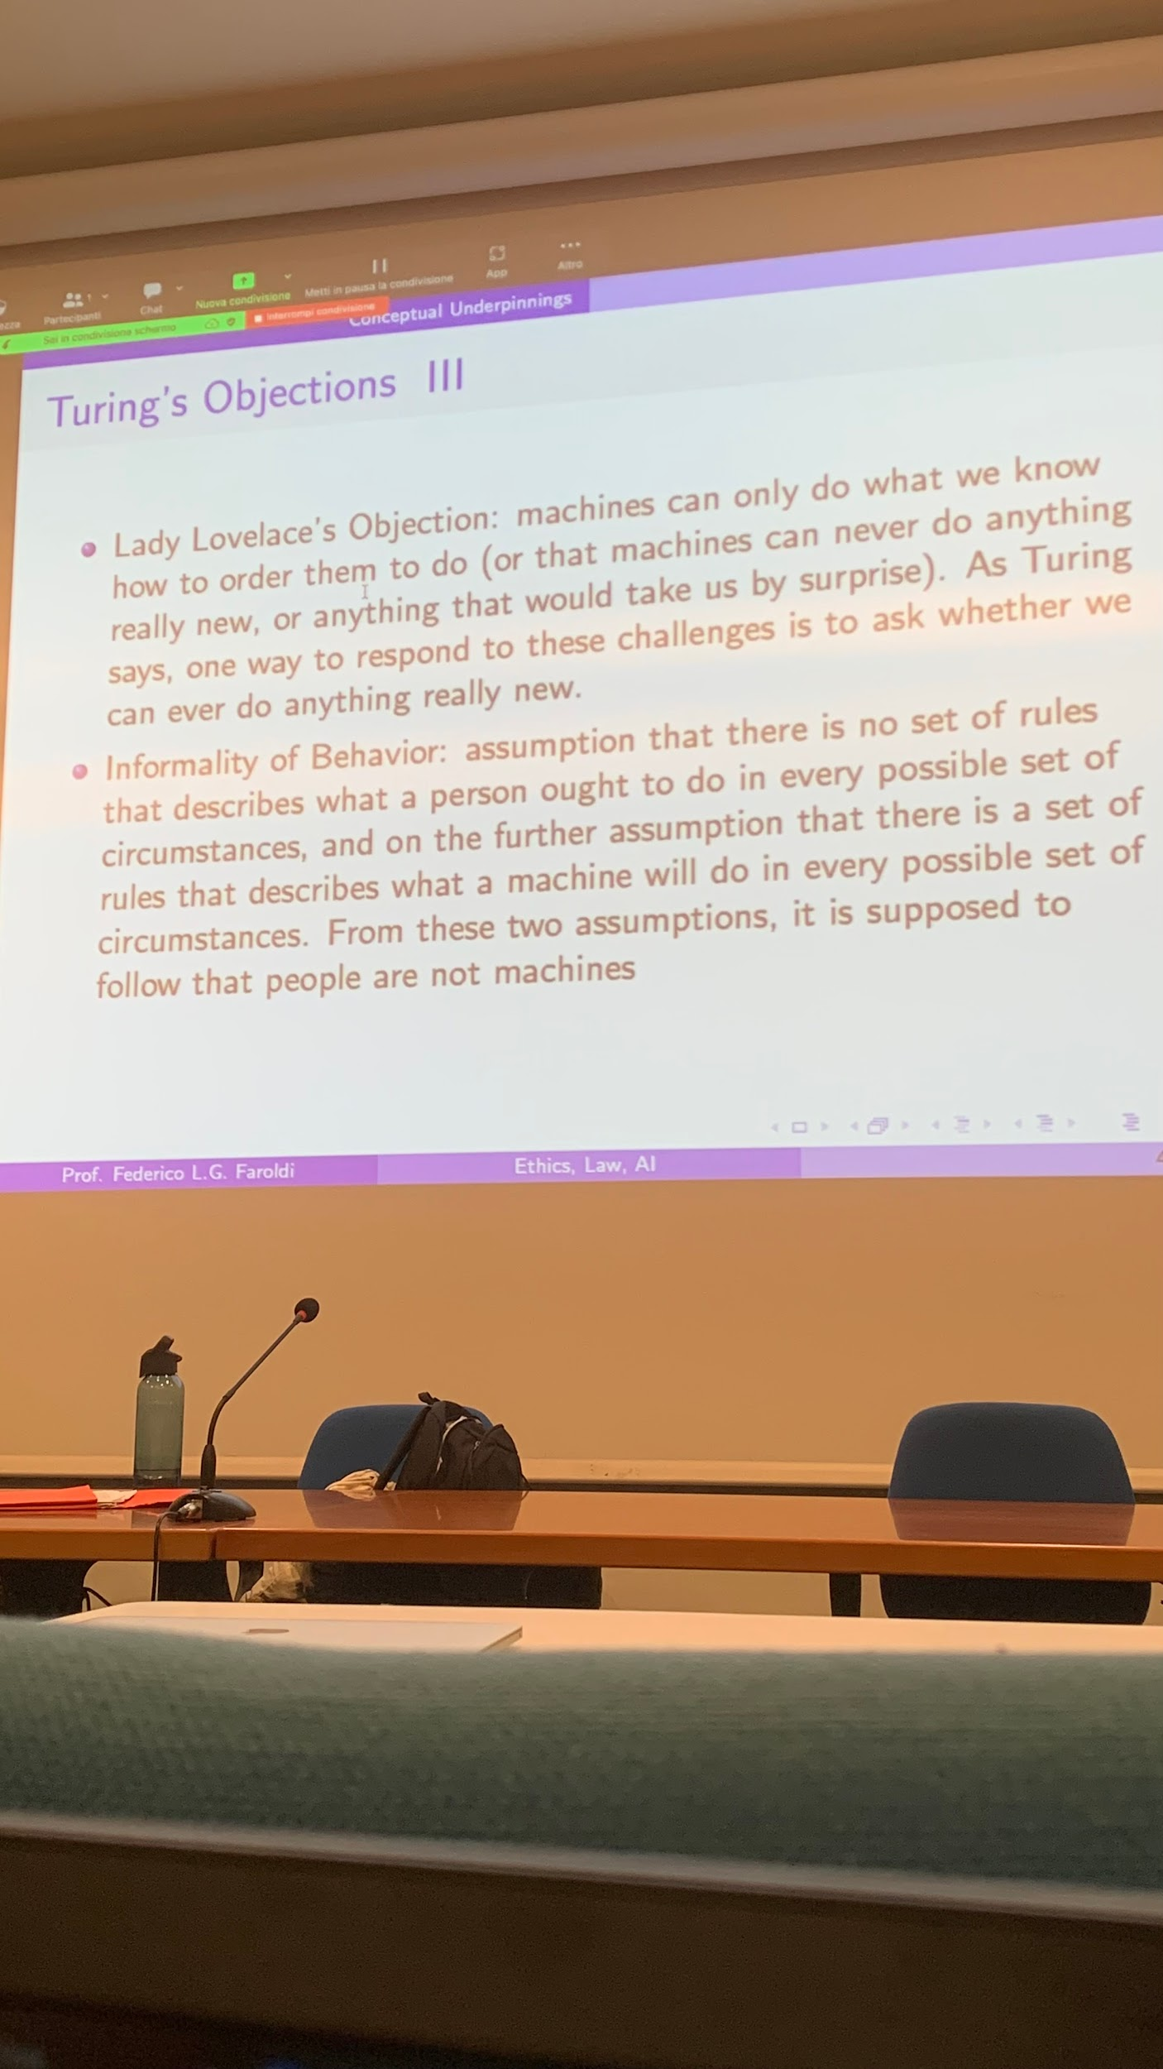

## **7. Argument from continuity in the nervous system**

**Objection**: the brain is not a discrete-state machine

The neurons system is not a discremete machine. A difference is a neuron can have huge differences. Can not mimic a human brain. Continuous machines are different but with regolutsions is impossible for the interrogated to distinguish between which one +compl

Objection not entirely correct. A continuous machines (neurons system) a small error can make huge difference in final output. But this is also true in discrete machine. We have to understand better the difference between continuous and discrete machines.

Turing answers is not clear.

## **8. The argument from informality of behaviour**

**Objection**: there is no way to prepare the machine for every possible combination that may appear in the real-world by explicitly programming it

Turing: eventually we will figure out more and more rules but never all of them, so he supports this objection as he is not giving a practical way to engineer beyond this limitation. Autonomous cars will be the first real-world application to refute this one

OBJECTION: a machine not able to mimic the human behaviour. If you actually go and think about the laws of conduct law.

## **9. The argument from extra-sensory perception**

**Objection**: if someone have telepathic abilities he can figure out which card the judge has in his hands. While the machine can only do random guesses.

Turing: put subject in a telepath-proof room